Curriculum Vitae
Petros Zourdoumis
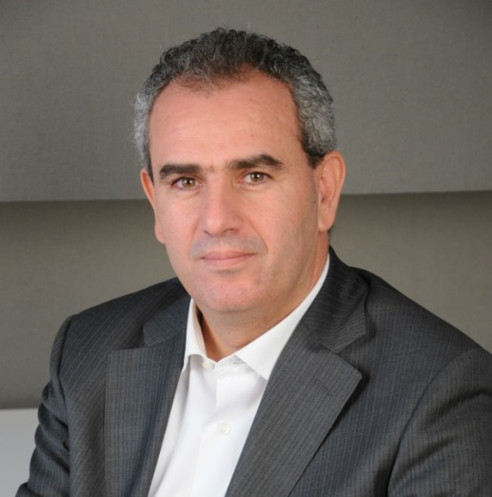
Founder ODReurope
General Director ADR point
Fellow at the NCTDR U.S.A.
President of the AGM
T. +30 2310 512777
M. +30 6944 305474
E. info@adrpoint.gr
E. generaldirector@adrpoint.gr
W.www.adrpoint.com

Petros Zourdoumis is a law graduate, an economist and an experienced ADR & ODR specialist with background in law, economics and online dispute resolution. He is a practicing mediator & negotiator with over 150 commercial, financial and family business domestic & cross-border mediations and a large number of negotiations. He has mediated complex disputes between multinational & local companies, he has handled many multiparty mediations and high value commercial disputes and he has introduced bank mediation in Greece.
He holds a BA in Economics (Aristotle University, Greece), an LL.B in English Law University of Essex-UK), an LL.M in European Management Law (Leicester University-UK) and many mediation & negotiation accreditations, such as Civil & Commercial Disputes (ADR group, UK- AKKED - Greek Ministry of Justice), Workplace Disputes (ADR group, UK), Cross border Disputes (INADR, USA), Family Disputes (KEDIP- MKK.e.V) (Successful Negotiations, Essential Strategies and Skills (UoM, USA), Master Class in Negotiations (ADR Center, Italy), Bank & insurance Disputes (Financial Ombudsman, Greece) etc.
He is the General Director of ADR point - Center for Alternative Dispute Resolution, the largest Mediation Center in Greece and South East Europe which is the seat of the International Mediation Institute Qualified Assessment Program for IMI Certification of Mediators in Greece, runs its own cross border network of mediators in many countries and develops IT systems for alternative dispute resolution. He is a member of the Central Mediation Committee of the Greek Ministry of Justice, President of the Association of Greek Mediators, Appointed mediation expert at the Court of First Instance, Fellow at the National Center for Technology & Dispute Resolution (USA), Founder of ODReurope, one of the largest entities worldwide working with practitioners, corporations, state bodies & professionals towards implementing technology in ADR, Member of the Working Team for Online Justice, etc.
He is speaker and panelist in world conferences and national and international working groups for ADR, ODR & e-justice, such as Creighton University-Cyberweek, Madrid European forum for EU ADR Directive & EU ODR Regulation, The Prague ODR Conference, The ICC Paris ODR Conference for Access to Justice, The Zagreb Mediation Conference, The Istanbul ODR Conference, The Brussels ADR Assembly, organized by the European Commission, The Sofia ADR/ODR conference, The University of Cagliari International Mediation Congress for ADR professionals etc.

